**2. Git-HOL**

**cd ~/GitDemo**

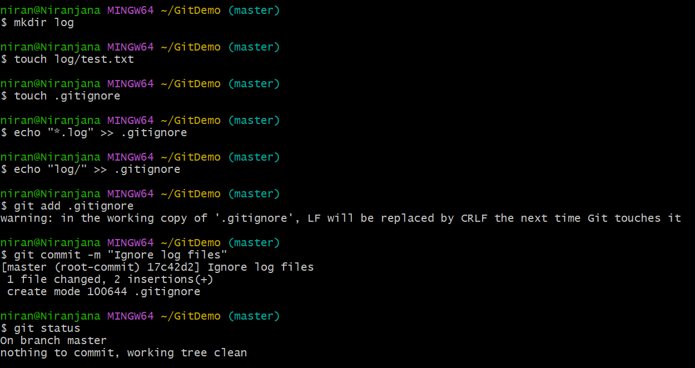

**Create test files and folder to ignore**

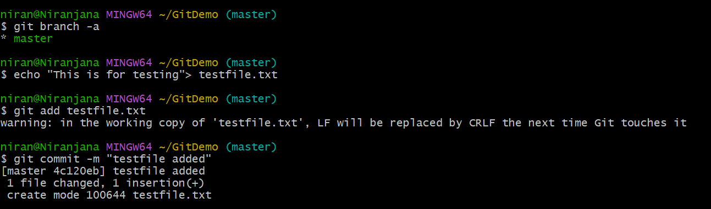

**Create a .gitignore file**

Touch .gitignore

* + echo "*.log" >> .gitignore
  + echo "log/" >> .gitignore
  + *.log
  + log/

Check git status

Git status

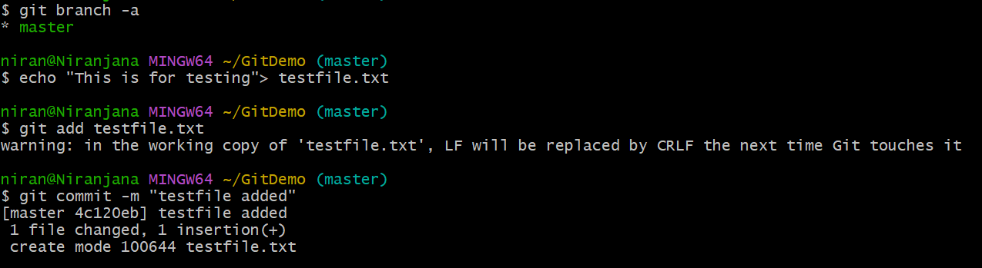

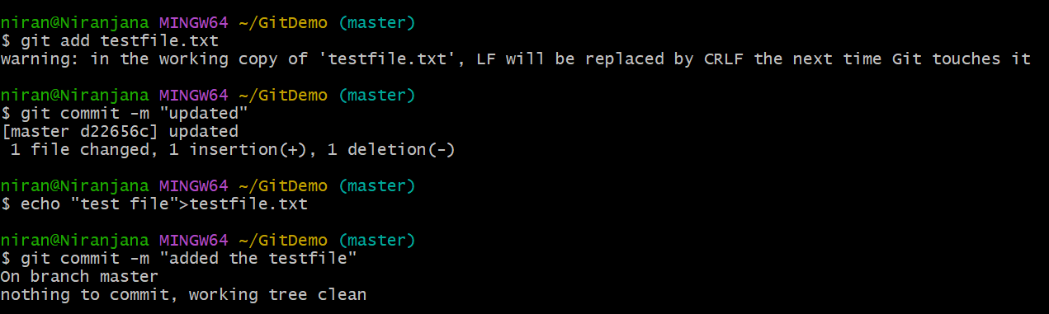

**Add and commit only .gitignore**

